[www.changingfuturesne.co.uk](http://www.changingfuturesne.co.uk)

We are a Charity that specialises in relationships to make positive changes and outcomes for children.

Working with around 300 families per year in our parental conflict programmes, including family mediation, we are experienced in providing interventions and support to parents, whether together or separated to have happier and healthier relationships with lower levels of well managed parental conflict.

Our team are also experienced in providing direct support to children affected by family relationship distress and challenges.

We are delighted to share with colleagues the intervention “Moving On” – which we have developed over several years and is described below.

Please contact Martin Todd [martin.todd@changingfuturesne.co.uk](mailto:martin.todd@changingfuturesne.co.uk) for further information about Changing Futures North East and our parental and family conflict work.

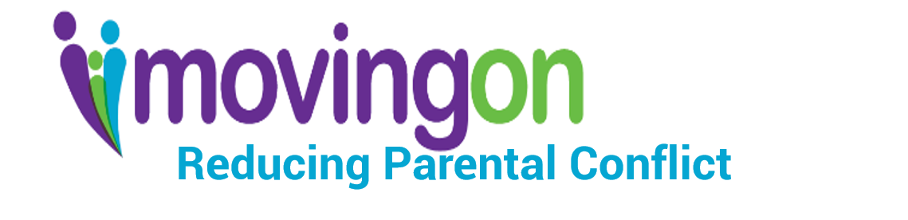

An intervention for separated parents or those who are together in a relationship that utilises the voice of the child to enable change and reduce parental conflict. The intervention is also suitable for other adults with caring responsibilities for children i.e. Grandparents

* An intervention that works with parents and children to help families who are stuck in enduring conflict to move on into better and healthier ways of relating and managing conflict
* Enables collaboration and cooperation between parents through helping them to see others’ perspectives and listen to children impacted by parental conflict
* Combines, individual and parental couple sessions together with targeted support interventions for children impacted by parental conflict that enables children’s voices to be heard by parents in conflict.

With a cohort of long term separated parents with unresolved conflict , ( >2 years separated) largely referred by Children’s Social Care Practitioners.

**Key Successes:**

* 57% of couples starting work with practitioners complete the work
* For those that complete:
  + 90% of participants- Improved awareness of  children's needs;
  + 71% of participants- Reduction in co-parental conflict;
  + 76% of participants- Improved co-parent relationship.

**Evaluation Data** (from Help and Support for Separated Families Innovation Fund Evaluation 2016)

All participants completed a survey to determined their level of parental alliance (the Parental Alliance Measure or PAM) an indicators or the co-parenting relationship.

Baseline data showed:

* 68% of parents were in problematic or dysfunctional* co-parenting relationship.
* Only 19% were within normal limits*

Post intervention scores showed “significant change in PAM Scores immediately post-support”

* 47% were within normal limits post support
* Only 13% were in dysfunctional category

Follow up evaluation 3-6 months after intervention showed:

“Significant improvement continue to be evident by the time of the survey, but drop compared to immediate post-support scores”

*Please note, the language for categories is determined by the measure.